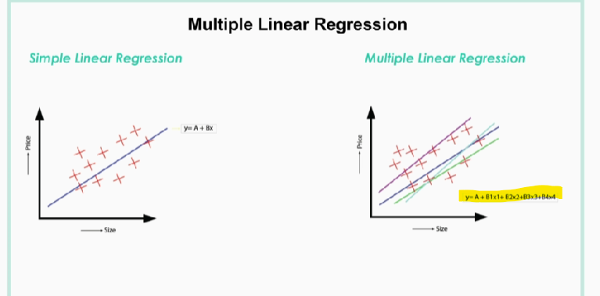

In the above image from highlighted formula we can see that multi linear regression have multiple independent variable or more than one input to predict output.

So the output will depends on each input, in multiple linear regression there will be a unique correlation between each input and the output will be found, these correlations are showed as four different lines